# **Lesson Objectives**

1. Modeling with Linear Functions
2. Applications with Linear Models
3. Piecewise-Defined (Linear) Functions

# **Modeling** with Linear Functions

To model a quantity that is changing at a constant rate with $f(x)=mx+b$, the following formula may be used:

$f(x)$**= (_________ rate of change, __________amount, or ______)·*___*+ (__________amount)**

* The constant **________** of change (changing amount) corresponds to the **_________** of the graph of *f*.
* The **___________ amount** (starting or fixed amount) corresponds to the ***___*-intercept**.
* **EXAMPLE:** Brand C soup contains 889 milligrams of sodium. Find a linear function *f* that computes the number of milligrams of sodium in *x* cans of Brand C soup. [2.2-28]

1. **_____________ your variables**. What information are we tracking?

Let *x* = **____________________________________**

Let *f*(*x*) = **____________________________________________________**

1. **Identify the** **___________ amount (when *___* is zero)**. Initial amount = **___**

Notice the initial (or starting) amount is not explicitly stated in this problem.

Because we are counting *x* cans of soup, there isn’t fewer than **______** cans of soup.

Also, with zero cans of soup, there’s also **_________** sodium.

So, it’s reasonable to assume that the initial amount must be zero.

1. **Identify the** **_____________ amount (rate)**. Changing amount = **_______**(increasing)

Since each can of soup has **________** mg of sodium, then the total sodium *f*(*x*) INCREASES by that amount, 889 mg, for each can of soup *x*.

The changing amount, then is +889 mg sodium.

1. **Write the _______________ for the linear function.**

$f(x)=$

$f(x)=$**____________________________________**

**_______________** or more simply: **___________________**

# **Applications** with Linear Models

* **EXAMPLE:** A 900-gallon tank is initially full of water and is being drained at a rate of 30 gallons per minute. Complete parts (a) through (d) below. [2.4.19]

1. **Write a linear function *W* that gives the gallons of water in the tank after *t* minutes.**
2. **Define your variables:**

Let *t* = **__________** in minutes

Let *W*(*t*) = **_________________________** after *t* minutes

1. **Identify initial amount:**

When *t* = **____**, draining hasn’t started yet, so tank is full at 900 gallons.

Initial amount = **_________** (keywords: 900-gallon tank is initially **______**)

1. **Identify changing amount (rate):**

The tank is **_______________** at a **__________** of **_______** gallons per minute.

Changing amount = **_______** (keyword: draining, which is **________________**)

1. **Write the formula:** *f*(*x*) = (changing amount)·*x* + initial amount

So, the formula is: **____________________________**

1. **How much water is in the tank after 4 minutes?**

Use the formula you just found to compute this.

After 4 minutes means *t* = **_____**:

Use ***W*(*t*) = – 30*t* + 900**, with *t* = 4.

*W*(4) = **____________________** = **_________________** = **___________**

So, after 4 minutes, there are **_________** gallons of water in the tank.

(go on to the next page)

1. **Graph function *W* and identify and interpret the intercepts. Choose the correct graph below.**

Recall from previous page that the function is: ***W*(*t*) = – 30*t* + 900**

|  |  |  |  |
| --- | --- | --- | --- |
| A. | B. | C. | D. |
|  |  |  |  |
|  |  |  |  |

The ***t*-intercept** is where ***__________*** (same thing as *y*) must be zero (that is ***____*** = 0).

Refer to the formula found earlier: $W\left(t\right)=-30t+900$

Set *W*(*t*) equal to zero to find the *t*-intercept. $_____=-30t+900$

Now, solve the equation for *t*.

$$\frac{-900}{ }=\frac{-30}{ }t$$

So, the *t*-intercept is at $(_______,0)$**. $_______=t$**

The ***W*-intercept** is where ***___*** = 0. Time = zero sec. (**___________**amount of water in tank).

Refer to the formula found earlier: $W\left(t\right)=-30t+900$

The *W*-intercept (or the *y*-intercept, *b*) is: $(0,__________)$.

1. **Find the domain of *W*.** (Use set-builder notation)

Remember that domain is ***___***, but with this function, the domain involves ***____***(time).

The tank **__________** draining at *t* = 0 minutes and it **_________** draining at *t* = 30 minutes.

So, the domain is: {t| **_______________** }. (the time is **___________** zero and 30 minutes)

# **Piecewise-Defined** (Linear) **Functions**

* **EXAMPLE:** The graph of $y=f(x)$ gives the speed limit $y$ along a rural highway $x$ miles from its starting point. [2.4.27]

1. What are the maximum and minimum speed limits along this stretch of highway?
2. Estimate the miles of highway with a speed limit of 45 miles per hour.
3. Evaluate $f(9)$, $f(24)$, and $f(3)$.
4. At what $x$-values is the graph discontinuous? Interpret each discontinuity.
5. **What are the maximum and minimum speed limits along this stretch of highway?**

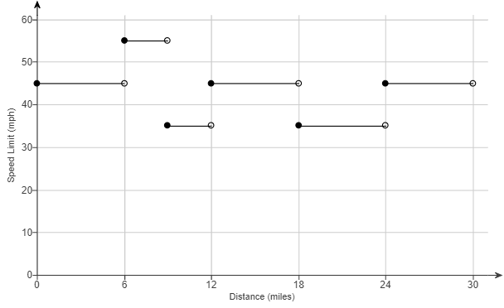

Maximum speed limit = **____**mph Minimum speed limit = **_____** mph

1. **Estimate the miles of highway with a speed limit of 45 miles per hour.**



Estimated miles of highway with speed of 45 mph = **___** pieces × **___** miles = **____** miles

(go on to the next page)

1. **Evaluate $f(9)$, $f(24)$, and $f(3)$.**



Use the **_____________** dot, not the open dot!

$f\left(9\right)=______$ The ***____***-coordinate when *x* = 9

$f\left(24\right)=_____$ The ***____***-coordinate when *x* = 24

$f\left(3\right)=______$ The ***____***-coordinate when *x* = 3

1. **At what $x$-values is the graph discontinuous? Interpret each discontinuity.**

**discontinuous:** where there is a “**_________**” in the graph, with another value **_____________** it. If you were to graph by hand, you need to **_____________** your pencil to continue the graph.



The graph is discontinuous at $x=________________________$

(NOTE: it is NOT discontinuous at $x=_______$ because there is nothing following it)

(go on to the next page)

* **EXAMPLE:** The graph of *y* = *f*(*x*) shows the amount of water *y* in thousands of gallons remaining in a swimming pool after *x* days. [2.4.32]

1. Estimate the initial and final amounts of water in the pool. (Type a whole number.)
2. When did the amount of water in the pool remain constant?
3. Approximate $f\left(2\right)$ and $f(4)$.
4. At what rate was water being drained from the pool when $3≤x≤5$?

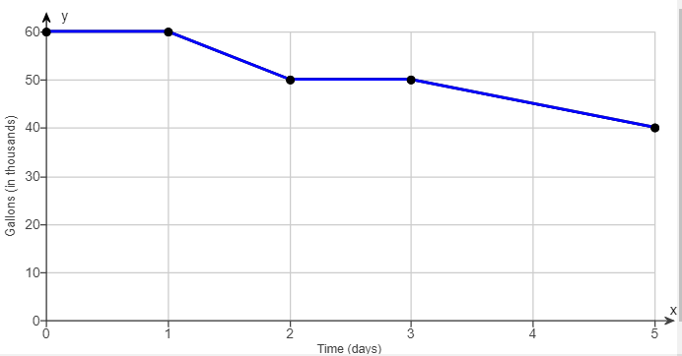

1. **Estimate the initial and final amounts of water in the pool. (Type a whole number.)**

Recall that the initial amount is the *y*-intercept, *b*, so find that location in the graph:

The initial amount of water in the pool was____**_________**______ gallons.

The final amount is the number of gallons seen at the end (far right) of the graph:

The final amount of water in the pool was ___**___________**_____ gallons.

1. **When did the amount of water in the pool remain constant?**

In the graph, a **constant** amount is **___________________** because it isn’t changing.



Choose the correct answer below

1. The amount of water in the pool was constant when $0≤x≤2$ and $2≤x≤4$.
2. The amount of water in the pool was constant when $0≤x≤1$ and $2≤x≤4$.
3. The amount of water in the pool was constant when $0≤x≤1$ and $2≤x≤3$.
4. The amount of water in the pool was constant when $0≤x≤2$ and $2≤x≤3$.
5. **Approximate $f\left(2\right)$ and $f(4)$.**



$f(2)$ means find **___**when $____=2$. (Use the graph) $f\left(2\right)=$

__**____**___

This means that after 2 days, there are about 50,000 gallons in the pool.

$f(4)$ means find **___** when $____=4$. (Use the graph) $f\left(4\right)=$

__**____**___

This means that after 4 days, there are about 45,000 gallons in the pool.

1. **At what rate was water being drained from the pool when $3≤x≤5$?**



When $3≤x≤5$, that’s between days 3 and 5. The **rate** is its **slope**.

$$rate=slope=\frac{rise}{run}=\frac{ }{ }=\frac{ }{ }= \frac{gallons}{day}$$

The water drained at a rate of **___________** gallons per day when $3≤x≤5$.

(go on to the next page)

* **EXAMPLE:** For the following function find the values of

1. *G*(– 18) **(b)** *G*(3) **(c)** *G*(– 1) [*Bittinger 2.2.97]

$G\left(x\right)=\left\{\begin{matrix}x-4, & if x≤-1 \\ x, & if x>-1\end{matrix}\right.$ These are **_____________** restrictions

**ALWAYS** start here **first** with **____________** part!

* + Only **_____** row “works” – the row you use **depends** on the **_______________** involved.
  + Work backwards – test your value for $x$ on the **______________** side of each row

1. $G(-18)$ means $____=-18$. **_________ it** in the **__________** (inequality) part first.

$$G\left(x\right)=\left\{\begin{matrix}x-4, & if x≤-1 \\ x, & if x>-1\end{matrix}\right.$$

$-18\begin{matrix}? \\ ≤\end{matrix}-1$**________** – use the **_________** row to plug in $x=-18$

$-18\begin{matrix}? \\ >\end{matrix}-1$**_________** – do **_______** use the second row for $x=-18$

Using the FIRST row of the function, $G\left(x\right)=_______________________$

$$G\left(-18\right)=___________________=________$$

1. $G(3)$ means $____=3$. **Test it** in the **domain** (inequality) part first.

$$G\left(x\right)=\left\{\begin{matrix}x-4, & if x≤-1 \\ x, & if x>-1\end{matrix}\right.$$

$3\begin{matrix}? \\ ≤\end{matrix}-1$**___________**– do **________**use the first row for $x=-18$

$3\begin{matrix}? \\ >\end{matrix}-1$**_________**– use the **____________**row to plug in $x=-18$

Using the SECOND row of the function, $G\left(x\right)=____$

$$G\left(3\right)=____$$

1. $G(-1)$ means $x=-1$. **Test it** in the **domain** (inequality) part first.

$$G\left(x\right)=\left\{\begin{matrix}x-4, & if x≤-1 \\ x, & if x>-1\end{matrix}\right.$$

$-1\begin{matrix}? \\ ≤\end{matrix}-1$**_________** – use the **_________** row to plug in $x=-1$

$-1\begin{matrix}? \\ >\end{matrix}-1$ FALSE – do NOT use the second row for $x=-1$

Using the FIRST row of the function, $G\left(x\right)=____________________$

$$G\left(-1\right)=__________________=______$$

* **EXAMPLE:** The charges for renting a moving van are $75 for the first 30 miles and $5 for each additional mile. Assume that a fraction of a mile is rounded up.

1. Determine the cost of driving the van 84 miles.
2. Find a symbolic representation for a function *f* that computes the cost of driving the van *x* miles, where $0<x≤100$.

(Hint: Express *f* as a piecewise-defined function) [*Lial 2.6-30]

**[SOLUTION]**

|  |  |  |
| --- | --- | --- |
| (Total = **____** miles) | **Price** |  |
| First **____** miles → → → → | $**____** |  |
| Miles remaining:  **____**– **____** =**____**  After first 30 miles, price is  $**____** each additional mile | $**___** × **___** = $**______** |  |
| Total price: | $**___** + $**____** = $**_____** |  |
|  | ANSWER: **___** | $$f\left(x\right)=\left\{\begin{matrix}75 & if 0<x≤30 \\ 75+5(x-30) & if 30<x≤100\end{matrix}\right.$$ |
| Test it!  need to use **______** row because $x=______$ miles | $$30<84≤100$$ is **_______** | Use **____**row: $f\left(x\right)=75+5(x-30)$ $$f\left(84\right)=75+5\left(84-30\right)$$ $$=75+5\left(54\right)$$ $$=75+270=\$345$$ |

1. $6570; $f\left(x\right)=\left\{\begin{matrix}75x & if 0<x≤30 \\ 75+5(x-30) & if 30<x≤100\end{matrix}\right.$
2. $645; $f\left(x\right)=\left\{\begin{matrix}75 & if 0<x≤30 \\ 75+5(x+30) & if 30<x≤100\end{matrix}\right.$
3. $345; $f\left(x\right)=\left\{\begin{matrix}75 & if 0<x≤30 \\ 75+5(x-30) & if 30<x≤100\end{matrix}\right.$
4. $645; $f\left(x\right)=\left\{\begin{matrix}75 & if 0<x≤30 \\ 75+5(x-30) & if 30<x≤100\end{matrix}\right.$

Sources Used:

1. Pearson MyLab Math *College Algebra with Integrated Review, 12th Edition*, Lial
2. Pearson MyLab Math *College Algebra with Modeling and Visualization, 6th Edition*, Rockswold
3. Pearson MyLab Math *Intermediate Algebra: Concepts and Applications, 10th Edition*, Bittinger